Create vm

Resize vm

Install internet information on machin

Click on webserver and add fetuare click next

Click next and next and install

Close

Site cant reached

Add network inbound rule on machin

Refresh page use public ip of machin

Azure region

Azure has data centres location across in world.

Azure region is geographic location that has one or more data centers

When host a resourse such as an azure virtual machine, it needs to be hosted on some physical infrastructure is an data center

These resources are made available to you via internet and azure portal is web interface that allows you to interact with the azure resources

Virual sizes

[Virtual Machine series | Microsoft Azure](https://azure.microsoft.com/en-us/pricing/details/virtual-machines/series/)

create Linux vm

Connect to linux

**Lab - Build a Linux Virtual Machine - Resources**

1. Connect with **Native SSH**

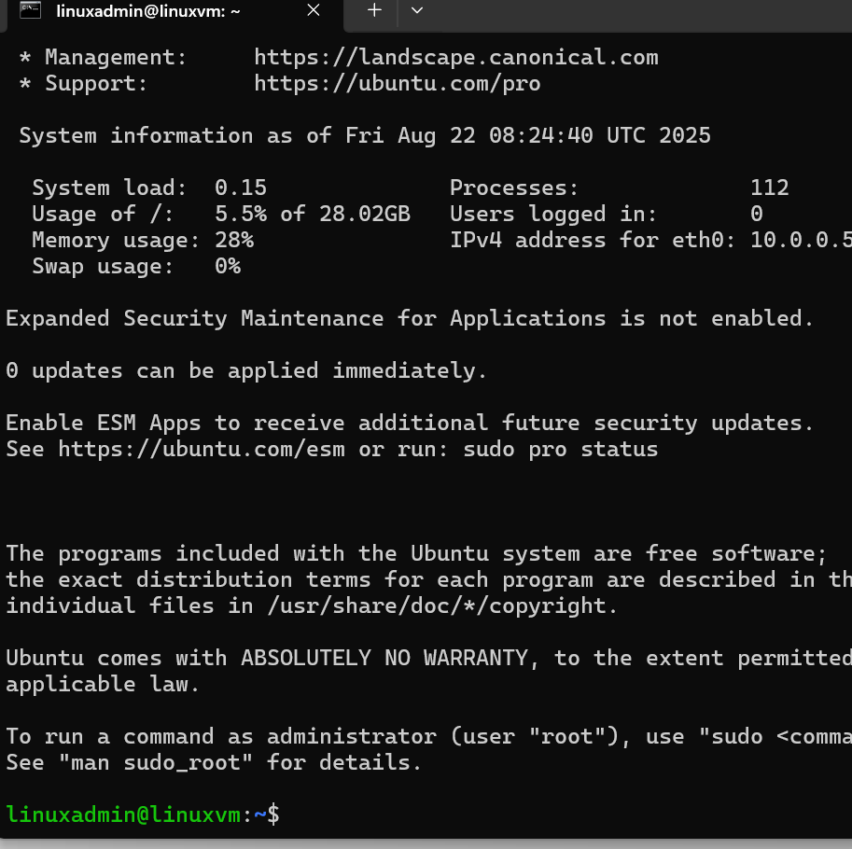

1. Putty
2. A screen shot of a computer

   AI-generated content may be incorrect.

Deploy webserver on linux vm

->Sudo apt update

Sudo apt install nginx

Add inbound rule Http – 80

Got to public ip -

 Lab - Deploying a Linux machine - SSH keys

Azure disk –

Storage volume managed by azure

Stard hdd – low cost, prformace issue

LUN -Logical unit number of the data disk. This value is used to identify data disks within the VM and therefore must be unique for each data disk attached to a VM.

Lab - Adding data disks

Added disk

What happened we stop machin

1. Created notepad file save in D drive and E drive on machin

stop/deallocate vm and start vm again

Connect to vm and verify drive D and E drive

File available on E drive only

Lab - Data Disks Snapshot

Read data copy of dick

1. Create 2 vm

Appvm02

Create snapshot data disk

Click on disk and click on create snapshot

Login to 2vm

Goto snapshot disk

Goto snapshot disk and click on crete disk

Now goto appvm02 and attach disk02 as existing disk

